Database System Engineering and Distributed Backend Development
Course Code: 25CS13002E
ROLL NO:2520030527
NAME: K.Vansika Reddy
SQL PRACTICE NOTES - ORDERS TABLE
Query 1: Create Data Base
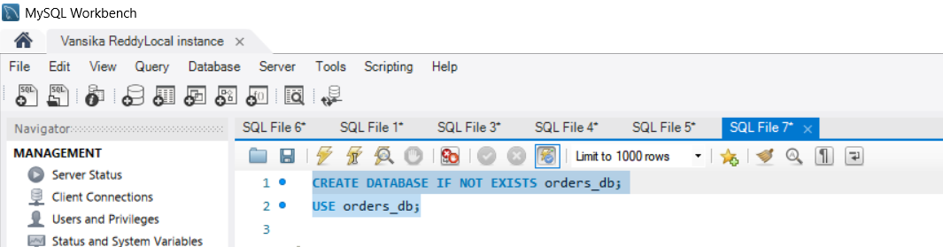

Output:
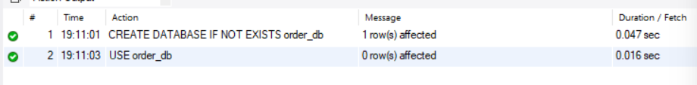
Query 2: CREATE TABLE
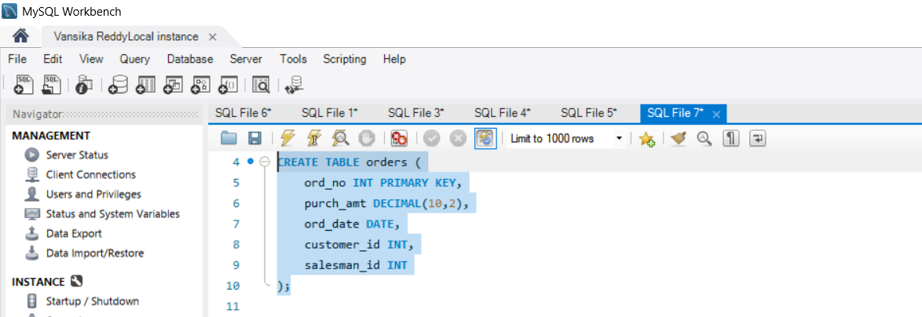

Output:
Query 3: INSERT DATA
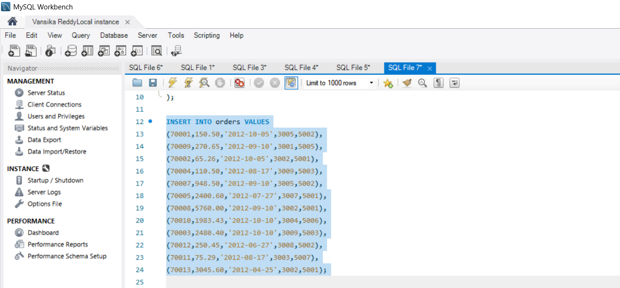

Output:

Query 4: WHERE CLAUSE
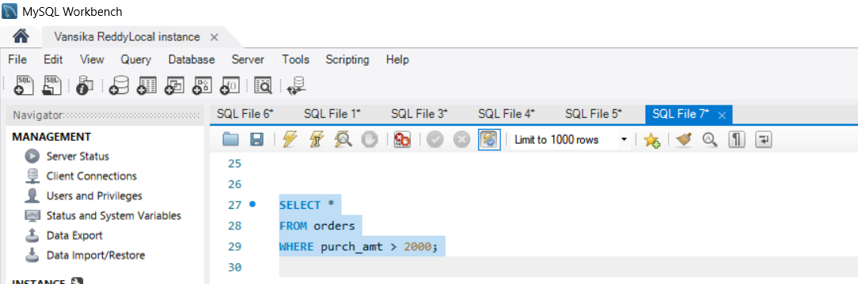

Output:
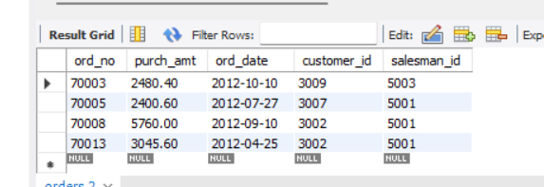

Query 5:WHERE CLAUSE
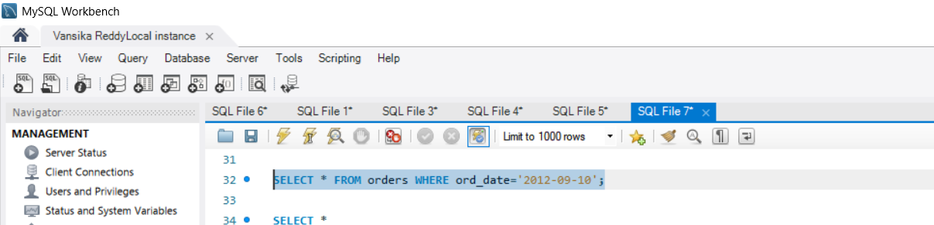
Output:
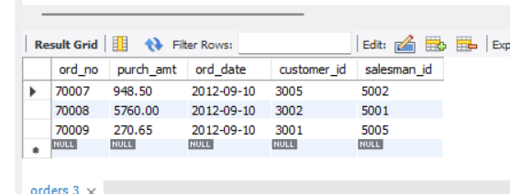

Query 6: WHERE CLAUSE
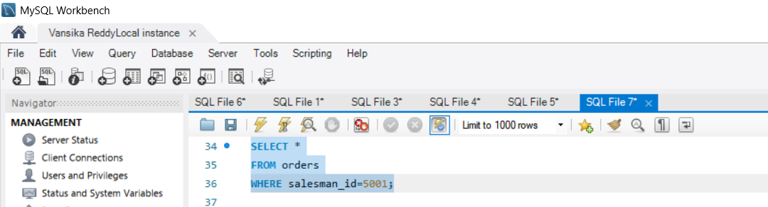

Output:
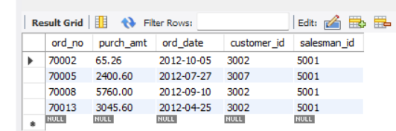

Query 7: ORDER BY
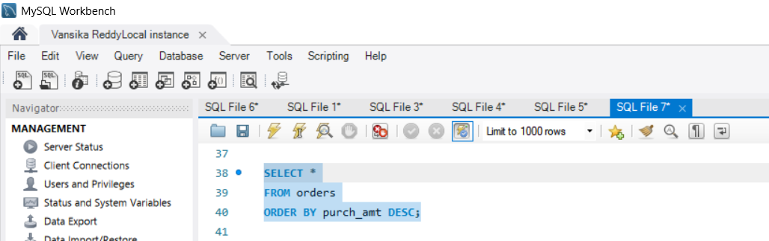

Output:
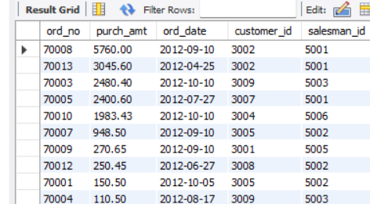
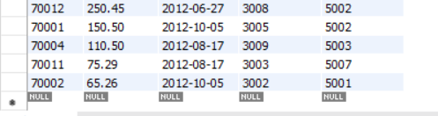

Query 8: ORDER BY
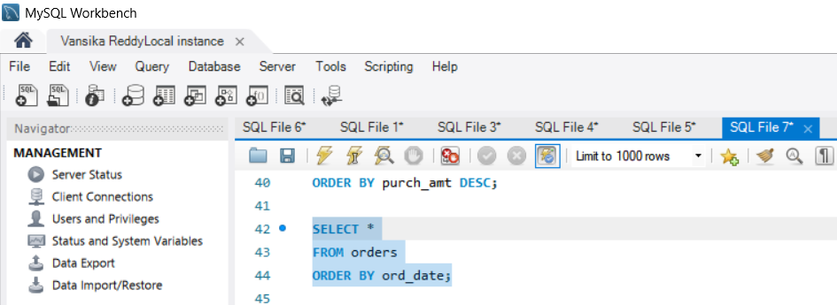

Output:
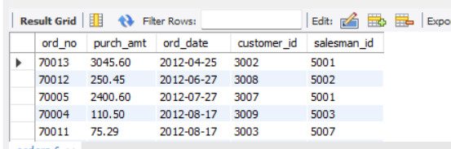
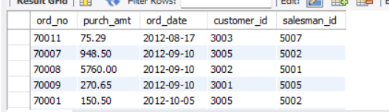
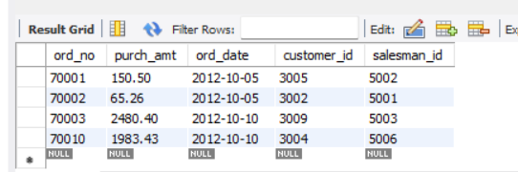

Query 9: SUM()
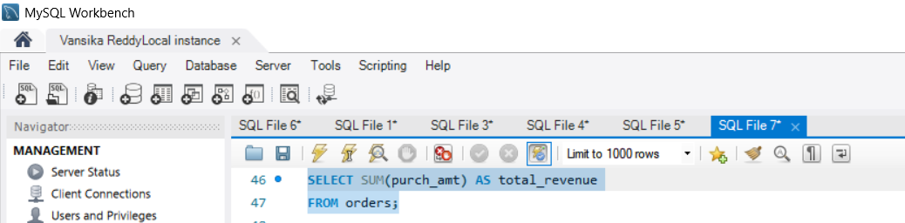

Output:
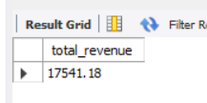

Query 10: AVG()
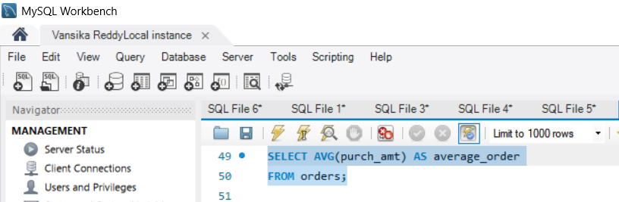

Output:
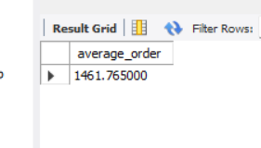

Query 11: MAX()
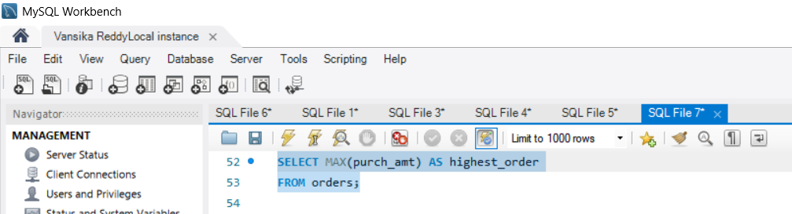

Output:
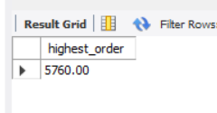

Query 12: MIN()
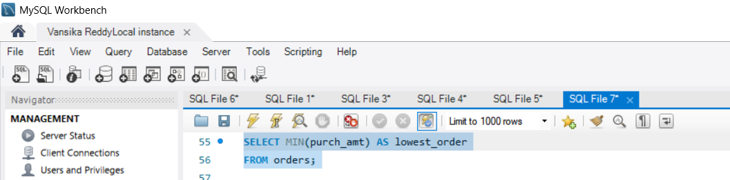

Output:
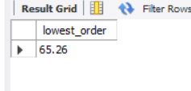

Query 13: COUNT()
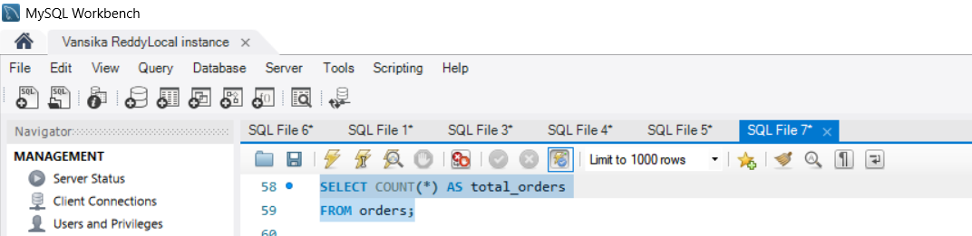

Output:
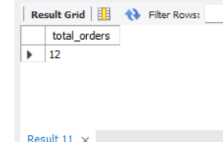

Query 14: GROUP BY
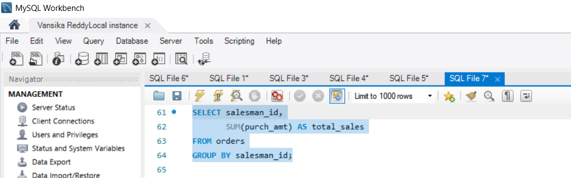

Output:
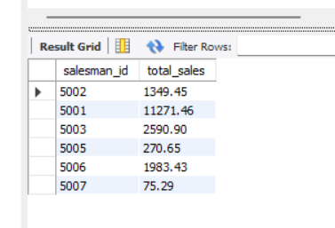

Query 15: GROUP BY
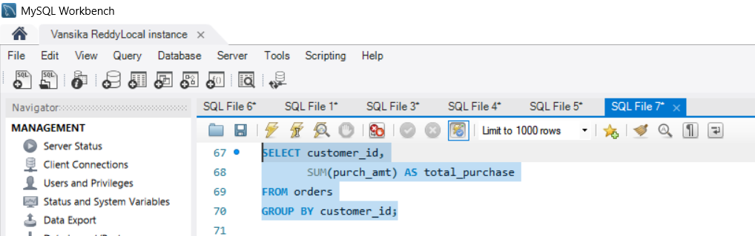

Output:
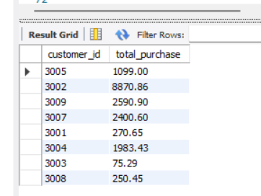

Query 16: GROUP BY + MAX()
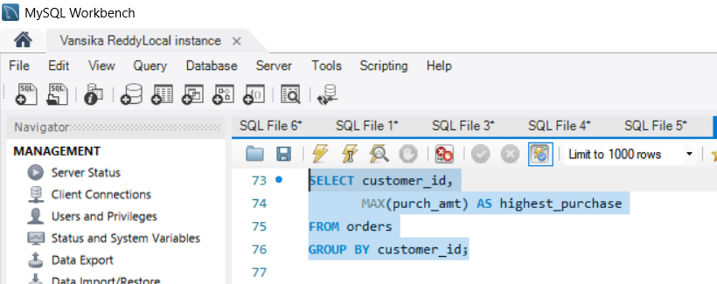

Output:
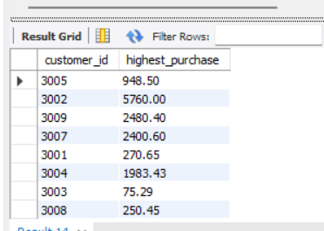

Query 17: GROUP BY + HAVING
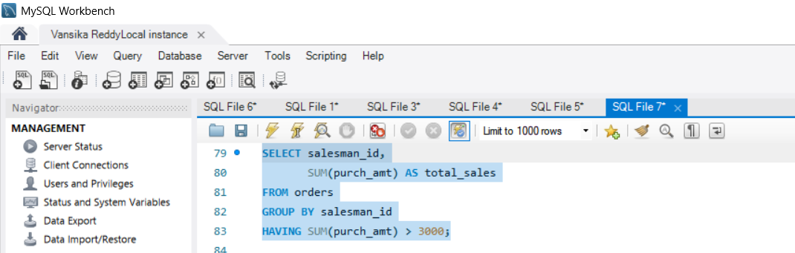

Output:
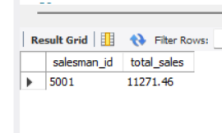

Query 18: GROUP BY + HAVING
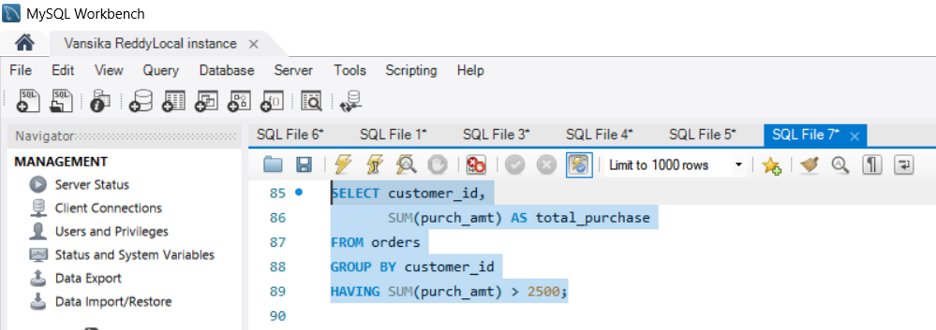

Output:
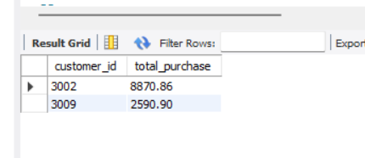

Query 19: GROUP BY + HAVING
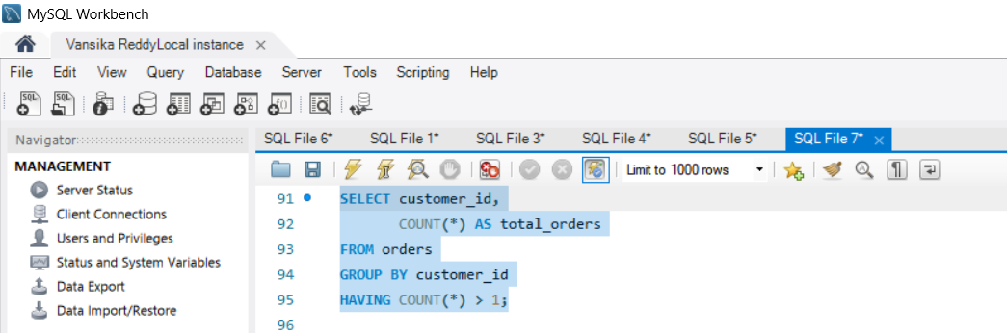

Output:
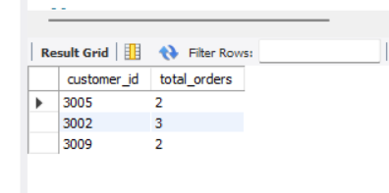

Query 20: GROUP BY + HAVING + ORDER BY
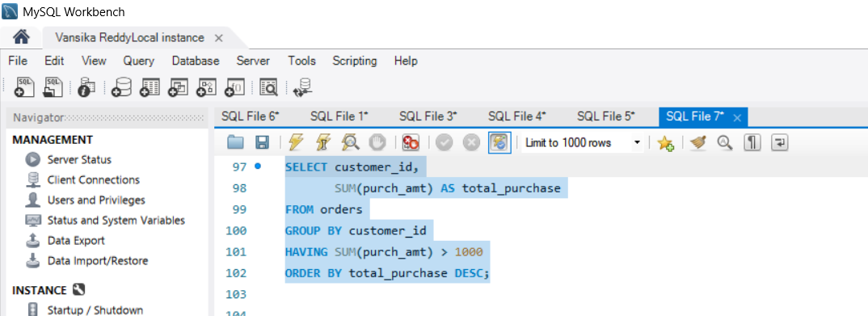

Output:
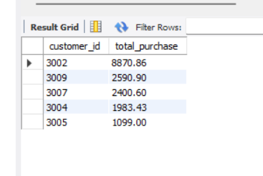

Query 21: BETWEEN + HAVING
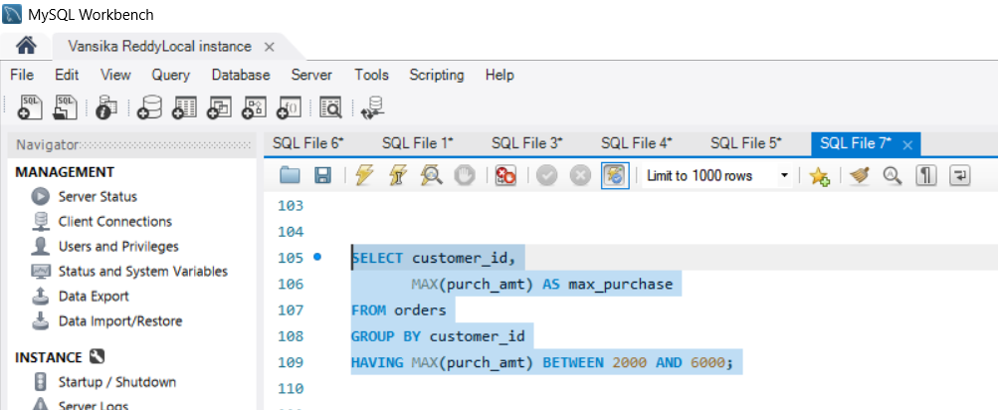

Output:
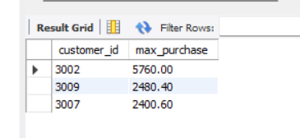

Query 22: COUNT + HAVING
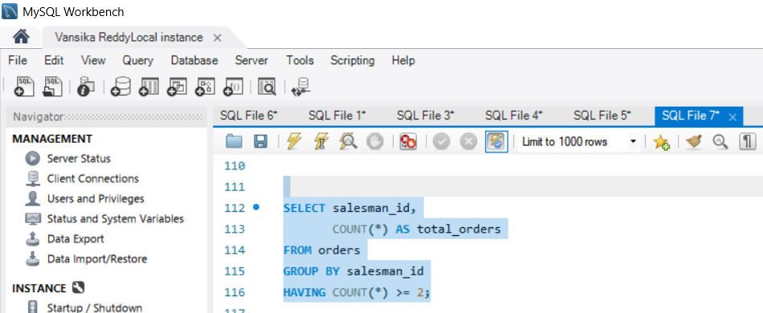

Output:
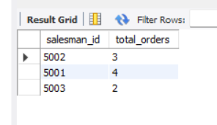
Query 23: MAX + GROUP BY + HAVING
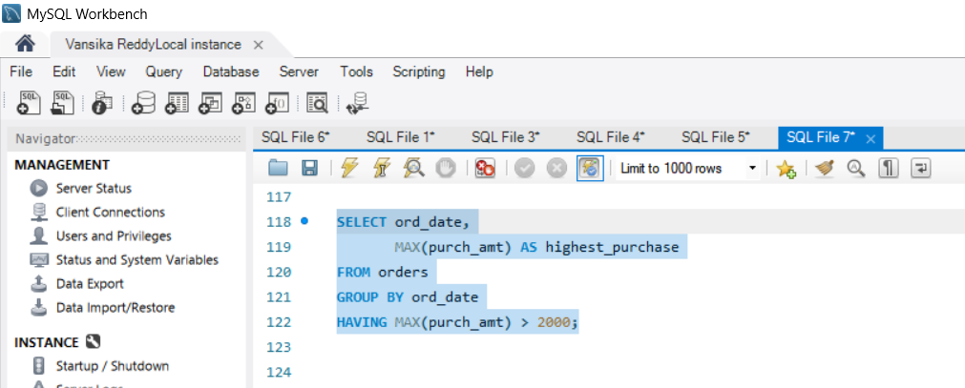

Output:
